# **Programming Assignment 1.1**

**Assignment Description**

Imagine you've built a time machine so you can travel back in time to meet the Greeks (specifically, Pythagoras and Hipparchus) who have helped give us amazing theorems (Pythagorean Theorem) and branches of mathematics (Trigonometry) that directly help us in our game development! Luckily, you're bringing your computer along with you (and, of course, a power source of some kind) so you can show off your programming skills.

In this assignment, you'll calculate the distance between two points and the angle a game character would need to move in to go from the second point to the first point.

**Why do we care?**

There are lots of times in game development where we need to know the distance between two points. For example, an NPC might determine which target to go after based on which one is closest to the NPC. What about angle? For the same example, the NPC needs to figure out how to move toward the selected target; having the angle lets us build the appropriate velocity vector for the NPC.

**The Pythagorean Theorem**

The Pythagorean Theorem tells us how to calculate the length of the hypotenuse of a right triangle. A picture (from Wikipedia) will really help here:

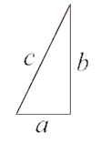

We know from the theorem that

c2 = a2 + b2

so if we take the square root of a2 + b2, we'll get c, the length of the hypotenuse.

**Getting Started**

Download the appropriate zip file for your OS below and unzip the file somewhere on your computer.

**2 Windows Programming Assignment 2 Materials**ZIP File

Download file

**2 Mac Programming Assignment 2 Materials**ZIP File

Download file

Open the project in Visual Studio.

**Important:** You MUST only add code as indicated by the comments in that file. If you don't, you're virtually guaranteed to fail all the test cases in the automated grader.

**Requirements**

The code I’ve provided in the Program.cs file reads in 4 floats for the x and y coordinates for two points and stores them in variables named **point1X**, **point1Y**, **point2X**, and **point2Y**. Your calculations (described below) must use those variables.

The picture below might help you with the following steps

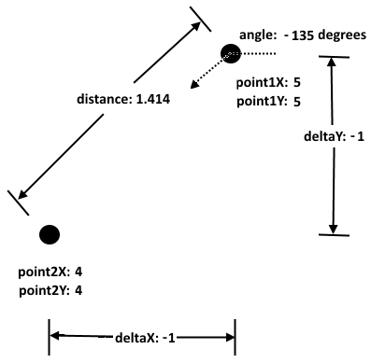

* Calculate the delta x and delta y between the two points; the term delta is often used in science and engineering for the difference or change between two values. The subtraction order matters when you calculate the angle in a later step , so be sure to subtract the first point values from the second point values
* Calculate the distance (as a **float**) between the two points using the Pythagorean Theorem. The distance we're calculating is just the length of the hypotenuse (c) where we calculated a (delta x) and b (delta y) in the previous step. You might want to explore the documentation for the **Math** class to help with this calculation; you can find that documentation at <https://msdn.microsoft.com/en-us/library/system.math(v=vs.110).aspx>. Remember you can use type casting to convert a **double** to a **float**
* Calculate the angle (as a **float**) we'd have to move in to go from point 1 to point 2 (0 degrees is directly to the right). Be careful here; we're not trying to calculate any of the angles inside the triangle. Think of it this way: your character is at the first point, facing directly to the right. What angle would you need to rotate by to be facing the second point?

CAUTION: Do NOT use **double** for your distance and angle variables; you'll fail in the autograder! Use **float** for those variables as described above

HUGE HINT: The **Atan2** method in the **Math** class can really help here, though you'll need to use type casting to store the result in the **float** for your angle

CAUTION: Read the Atan2 documentation carefully to make sure you pass the arguments into the method in the correct order. It's a common mistake to pass the arguments into the method in the wrong order, which of course leads to incorrect results

* Print the distance, a single space, and the angle

WARNING: Be sure to convert the angle from radians to degrees using **Math.PI** (and type casting again!) before printing it

* Do NOT print anything else in your output; if you do, you’ll confuse the automated grader and you’ll get a bad grade!

For example, if the point1 and point2 coordinates are 5, 5, 4, and 4 (as shown in the picture above), your output should be the following on a single line :

**1.414214 -135**

We’d typically label the distance and angle to tell the user what those numbers are, but that will just confuse the automated grader. You must print ONLY the actual distance and angle in your output, with the distance and angle appearing on a single line with a single space between them.

**Running Your Code**

Because of the code I included to work with the automated grader on Coursera, when you run your program the command prompt window will open and it will sit there doing nothing. To make your code run, type in 4 floats with a single space between each one and press the <Enter> key; your code should then run so you can check your output. For example, your input could be:

**5 5 4 4**

You can actually run your code again if you want to by typing in 4 floats with a single space between each one and pressing the <Enter> key again. When you’re ready to stop running your code, type q (for quit).

Here's what running the code multiple times with different inputs should look like. The first line is the float input (the coordinates for the two points), the second line is your output line, and so on:

**5 5 4 4**

**1.414214 -135**

**2 2 4 4**

**2.828427 45**

**q**

**Important Note:** The Coursera formatting makes it look like there's a blank line between each of the lines above, but there's not. The above output should be exactly 5 lines of input/output.

The image below shows my console window when I run the code multiple times as described above:

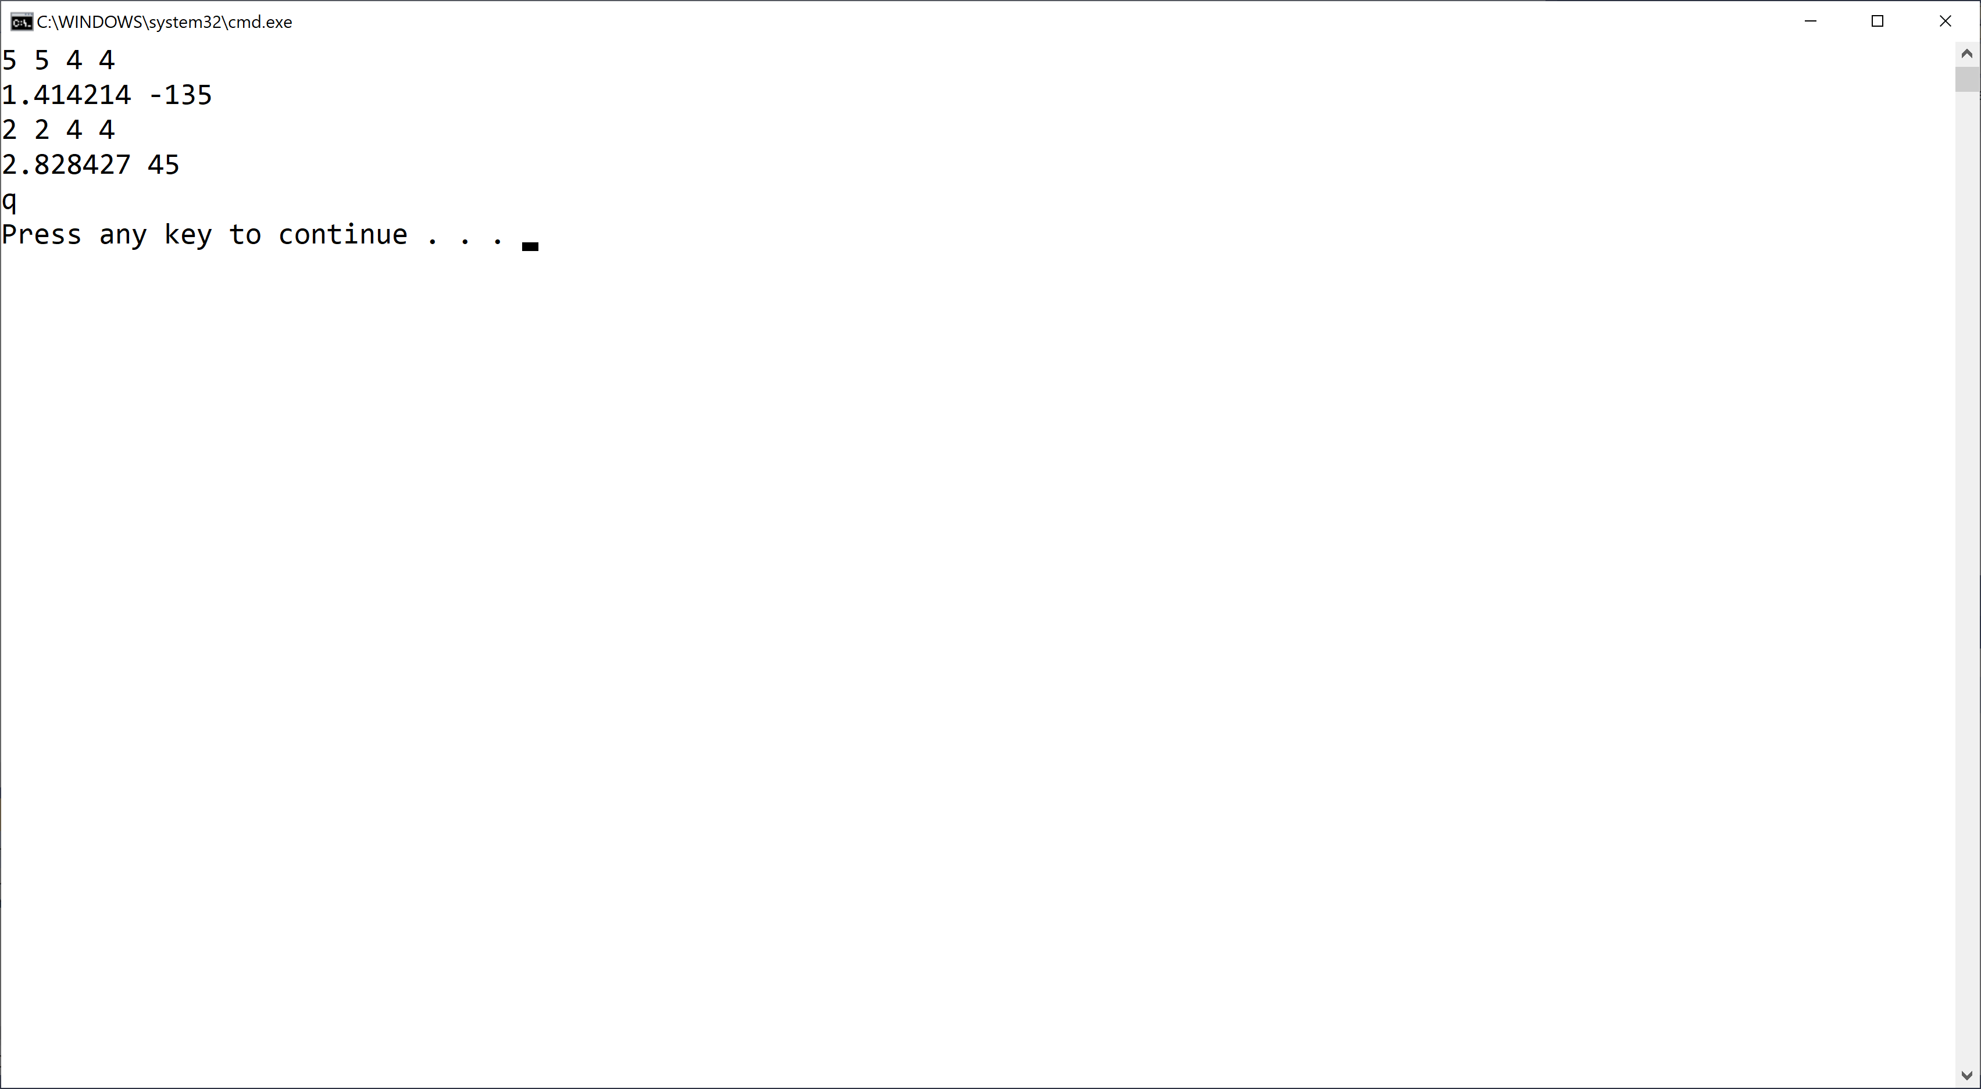

If your output doesn't match the image above EXACTLY (no extra words, characters, spaces, or blank lines) you'll fail all the test cases in the automated grader.

Mac users: You may have an extra blank line after the q, and it may not show the Press any hey to continue ... message. That's fine.

**Test Case Inputs**

The autograder uses the following set of test case inputs to test your code (1 test case per line):

**5 5 4 4**

**2 2 4 4**

**0 0 1 0**

**0 0 0 1**

**0 0 -1 0**

**0 0 0 -1**

**2 2 -4 4**

**2 2 4 -4**

**6 5 4 3**

**3 4 5 6**

You should figure out what the expected results are for each test case input and make sure your code is generating those expected results in the required format before submitting your code for grading.

**The Math Looks Too Hard To Me**

The math isn't nearly as bad as it looks at first glance. To calculate the delta x and delta y, all you need to do is subtraction. To calculate the distance between the two points, you need to square the delta x and delta y (multiply them by themselves), add the squares together, and take the square root of the result (use the appropriate method in the **Math** class to do that part). Finally, to calculate the angle between the two points, use the **Atan2** method in the **Math** class; you'll need to carefully read the documentation for that method to call it appropriately, of course. That's all the math you need to do.

**Taking Small Bites**

Solving this problem is a big step compared to the exercises, but that's why you shouldn't try to chew it up all in one bite. Just do each step above, one at a time, in order, and you'll see that you can do it. Although there are a few things for which you'll need to read documentation or do Google searches, if you tackle the assignment one step at a time you should be fine. Building a game is the same way, by the way. If we start thinking "How am I going to program this entire game?" it can be pretty intimidating! If we think in the much smaller steps we actually implement to eventually build a game, it becomes a much more achievable task.

**Common Problems**

Here are a couple things you should check:

1. You have to start with the Visual Studio project I gave you in the assignment materials and add your code in the section indicated. The code I gave you includes the appropriate structure for the automated grader to work. If you don't do this, you'll almost definitely fail all the test cases in the automated grader.
2. I give you an example in this assignment (and all assignments) for what output you should get when you run the code multiple times. Be sure to try that example; if your code doesn't generate output exactly as shown in the example, your code isn't working properly
3. Remember that you'll need to use type casting to use the **Math** class with your **float** variables

**Submitting Your Solution**

Go to the LMS and submit your Project to **Assignment 1**.